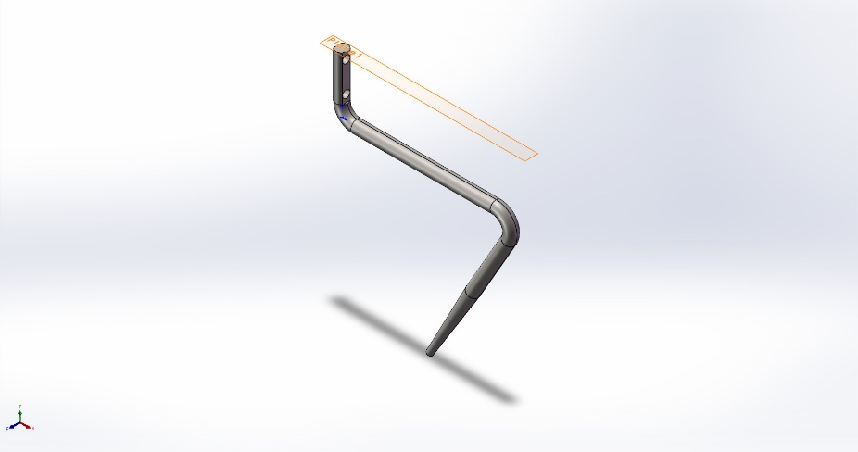
  Simulation of blenderaugershortonly
  Date: Sunday, January 4, 2026
  Designer: Solidworks
  Study name: blade analysis small
  Analysis type: Static
  Table of Contents
  Description 1
  Assumptions 2
  Model Information 2
  Study Properties 3
  Units 3
  Material Properties 4
  Loads and Fixtures 4
  Connector Definitions 5
  Interaction Information 5
  Mesh information 6
  Sensor Details 7
  Resultant Forces 7
  Beams 7
  Study Results 8
  Conclusion 10

Description
No Data

Assumptions

Model Information

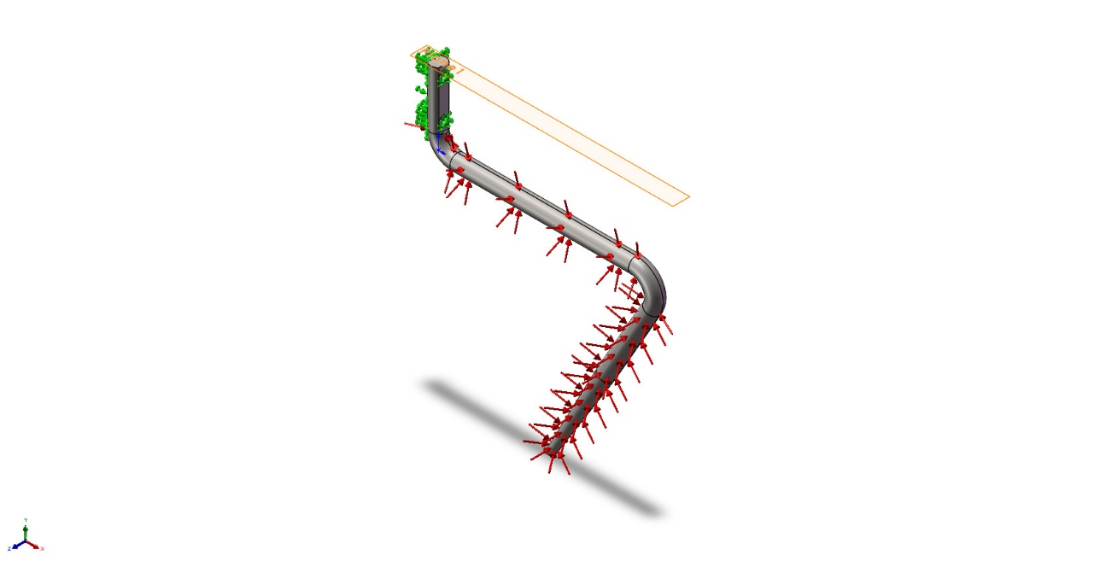
Model name: blenderaugershortonly
Current Configuration: 默认
Solid Bodies
Document Name and Reference | Treated As | Volumetric Properties | Document Path/Date Modified
Split Line1  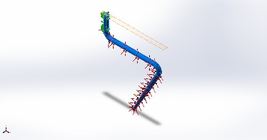 | Solid Body | Mass:0.0931969 kg  Volume:1.16496e-05 m^3  Density:8,000 kg/m^3  Weight:0.91333 N | C:\Users\User01\Desktop\vffs\design\design\blenderaugershortonly.SLDPRT  Jan 4 01:03:50 2026

Study Properties
Study name | blade analysis small
Analysis type | Static
Mesh type | Solid Mesh
Thermal Effect: | On
Thermal option | Include temperature loads
Zero strain temperature | 298 Kelvin
Include fluid pressure effects from SOLIDWORKS Flow Simulation | Off
Solver type | Automatic
Inplane Effect: | Off
Soft Spring: | Off
Inertial Relief: | Off
Incompatible bonding options | Automatic
Large displacement | Off
Compute free body forces | On
Friction | Off
Use Adaptive Method: | Off
Result folder | SOLIDWORKS document (C:\Users\User01\Desktop\vffs\design\design)

Units
Unit system: | SI (MKS)
Length/Displacement | mm
Temperature | Kelvin
Angular velocity | Rad/sec
Pressure/Stress | N/m^2

Material Properties
Model Reference | Properties | Components
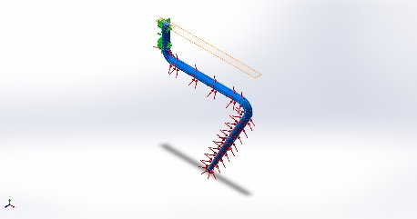 |  | SolidBody 1(Split Line1)(blenderaugershortonly)
  Name: | AISI 304
  Model type: | Linear Elastic Isotropic
  Default failure criterion: | Max von Mises Stress
  Yield strength: | 2.06807e+08 N/m^2
  Tensile strength: | 5.17017e+08 N/m^2
  Elastic modulus: | 1.9e+11 N/m^2
  Poisson's ratio: | 0.29
  Mass density: | 8,000 kg/m^3
  Shear modulus: | 7.5e+10 N/m^2
  Thermal expansion coefficient: | 1.8e-05 /Kelvin
Curve Data:N/A

Loads and Fixtures
Fixture name | Fixture Image | Fixture Details
Fixed-2 | 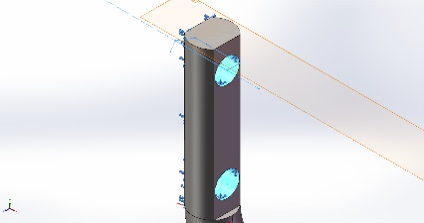
  Entities: | 3 face(s)
  Type: | Fixed Geometry
Resultant Forces
Components | X | Y | Z | Resultant
Reaction force(N) | 0.00558717 | -0.0377856 | 3.52518 | 3.52538
Reaction Moment(N.m) | 0 | 0 | 0 | 0

Load name | Load Image | Load Details
Pressure-1 | 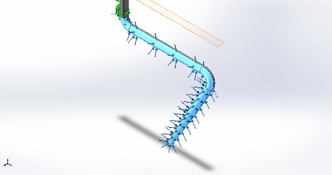
  Entities: | 5 face(s)
  Type: | Normal to selected face
  Value: | 2,000
  Units: | N/m^2
  Phase Angle: | 0
  Units: | deg

Connector Definitions
No Data

Interaction Information
No Data

Mesh information
Mesh type | Solid Mesh
Mesher Used: | Blended curvature-based mesh
Jacobian points for High quality mesh | 16 Points
Maximum element size | 1.47406 mm
Minimum element size | 0.491348 mm
Mesh Quality | High

Mesh information - Details
Total Nodes | 49011
Total Elements | 31332
Maximum Aspect Ratio | 10.882
% of elements with Aspect Ratio < 3 | 99.9
Percentage of elements with Aspect Ratio > 10 | 0.016
Percentage of distorted elements | 0
Time to complete mesh(hh;mm;ss): | 00:00:02
Computer name:

Mesh Quality Plots
Name | Type | Min | Max
Quality1 | Mesh | - | -
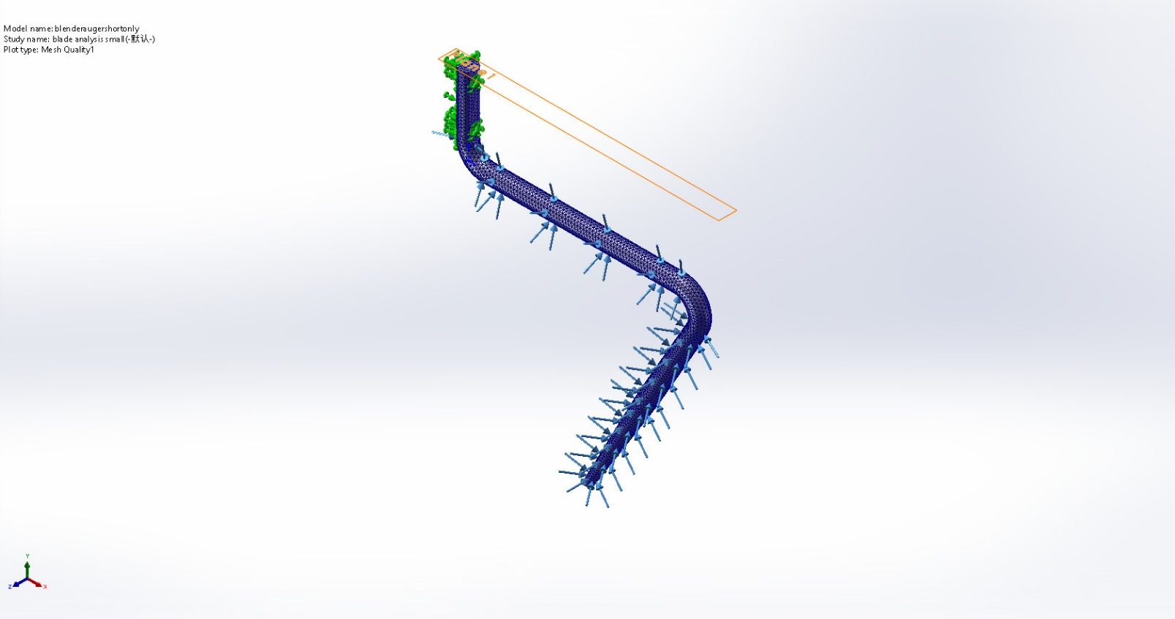
blenderaugershortonly-blade analysis small-Quality-Quality1

Sensor Details
No Data

Resultant Forces

Reaction forces
Selection set | Units | Sum X | Sum Y | Sum Z | Resultant
Entire Model | N | 0.00558717 | -0.0377856 | 3.52518 | 3.52538

Reaction Moments
Selection set | Units | Sum X | Sum Y | Sum Z | Resultant
Entire Model | N.m | 0 | 0 | 0 | 0

Free body forces
Selection set | Units | Sum X | Sum Y | Sum Z | Resultant
Entire Model | N | -9.35514e-05 | 0.000199017 | 0.00145948 | 0.00147595

Free body moments
Selection set | Units | Sum X | Sum Y | Sum Z | Resultant
Entire Model | N.m | 0 | 0 | 0 | 1e-33

Beams
No Data

Study Results

Name | Type | Min | Max
Stress1 | VON: von Mises Stress | 2.444e+00N/m^2  Node: 19 | 9.994e+06N/m^2  Node: 20
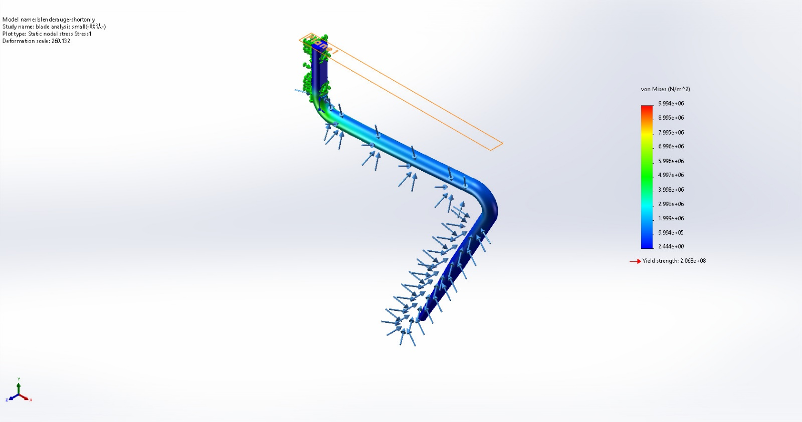
blenderaugershortonly-blade analysis small-Stress-Stress1

Name | Type | Min | Max
Displacement1 | URES: Resultant Displacement | 0.000e+00mm  Node: 5 | 5.659e-02mm  Node: 7
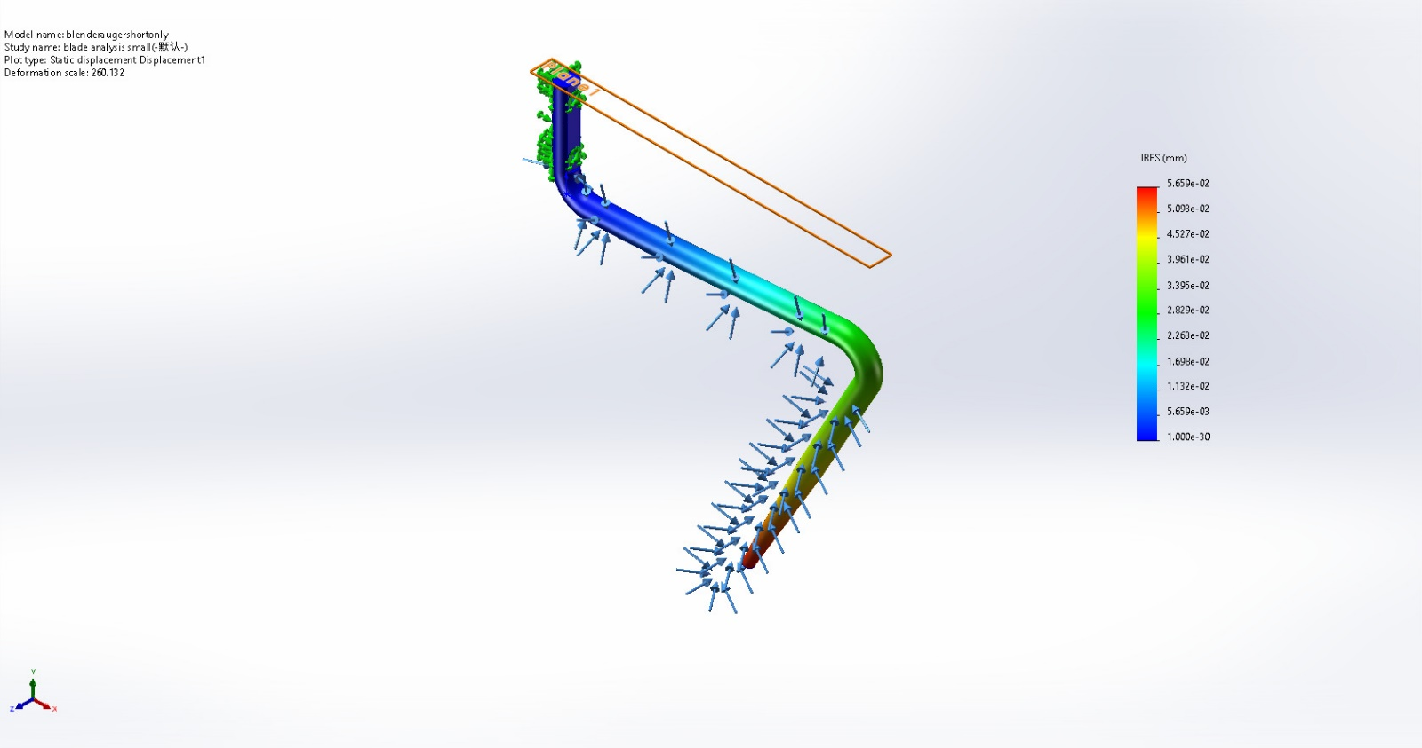
blenderaugershortonly-blade analysis small-Displacement-Displacement1

Name | Type | Min | Max
Strain1 | ESTRN: Equivalent Strain | 4.931e-11  Element: 5584 | 3.566e-05  Element: 7548
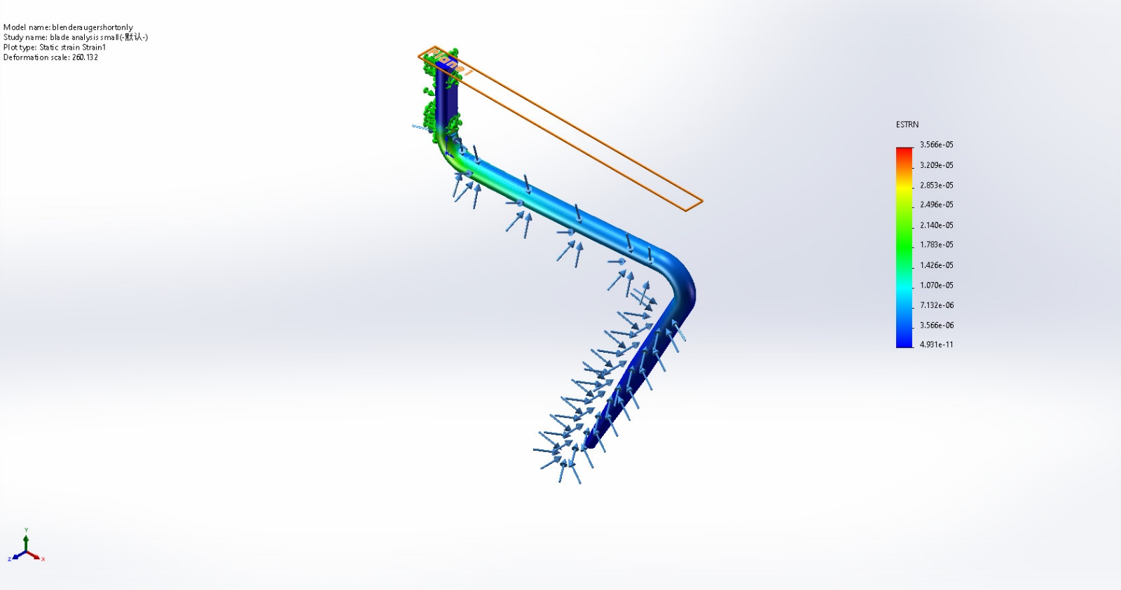
blenderaugershortonly-blade analysis small-Strain-Strain1

Name | Type | Min | Max
Factor of Safety1 | Max von Mises Stress | 2.069e+01  Node: 20 | 8.463e+07  Node: 19
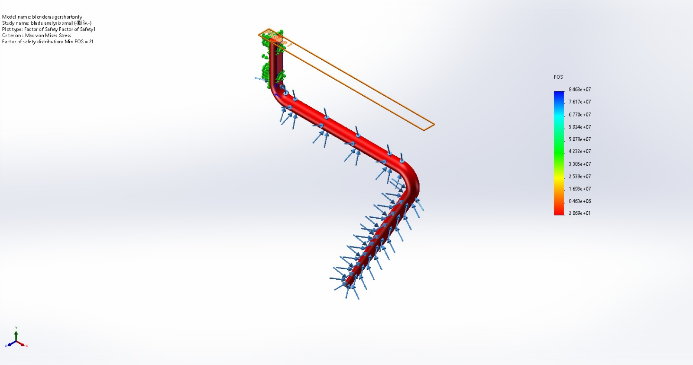
blenderaugershortonly-blade analysis small-Factor of Safety-Factor of Safety1

Conclusion

